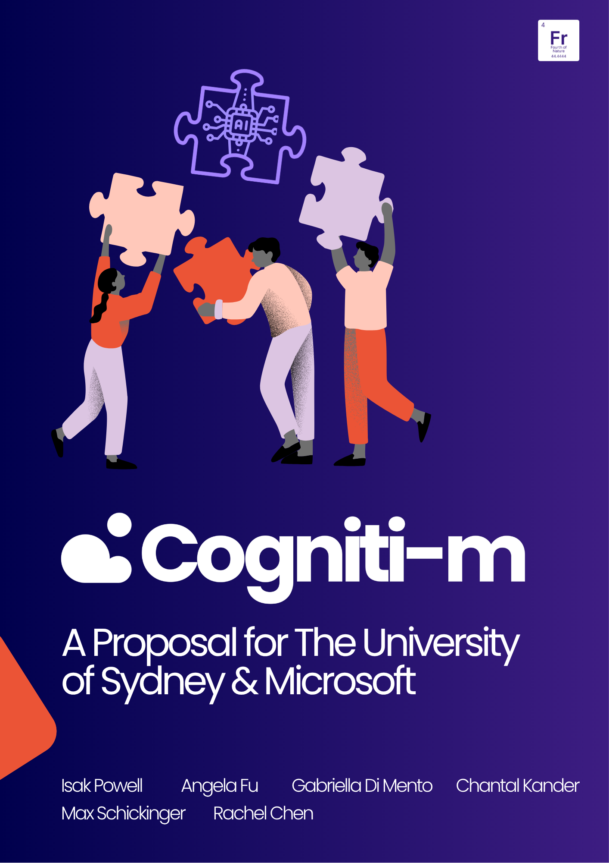

Contents
Contents 2
Executive Summary 4
Introduction 5
Problem Statement 6
Project Aims and Objectives 6
Approach 7
Survey Design and Methods 7
Figure 1: Survey flow diagram 8
Interview Design and Methods 8
Literature Review Design and Methods 9
Group Profile 10
Results and Findings 11
Primary Data - Survey 11
Figure 2: Demographic summary statistics 12
Student Views on AI in University 12
Figure 3: Student views on AI in university 13
Is There A Risk To Idea Generation? 13
Figure 4: Impact of AI on idea generation 13
AI Usage Methods 14
Figure 5: Student study habits 14
Figure 6: Changes to study habits over the past year 15
Primary Data - Interviews 15
Figure 7: Lecturer perspectives on AI usage in classrooms and/or assessments 16
Secondary Data 16
Discussion 19
Discussion of Results & Their Implications 19
Figure 8: Student opinions on the effect of AI on innovation and collaboration within university learning environments. 20
Our Recommendation: Cogniti-m 21
Features 21
Figure 9: Mid-fidelity mock-up of Cogniti-m integration into groups Canvas page 22
Originality 23
Addressing Need 24
Implementation & Ethical Considerations 24
Test of technical feasibility 24
Figure 10: Excerpt from testing - Agent suggests a brainstorming session to help the team find a problem 25
Implementation within university 26
Table 1: Cogniti-m Implementation Plan 26
Value to stakeholders 28
Limitations 29
Conclusion 30
References 32
Appendix 36
A: Survey 36
B: Interview Questions 40
C: Survey Data Tables 41
D: System Message 47
E: Cogniti-m Mid-Fidelity Mockup Figma Flow 48
F: Prototype in use and additional example outputs 49

Executive Summary
According to Microsoft (2025b), 84% of Australian workers use generative AI in the workplace, however, there has been limited effective AI integration across tertiary education to prepare graduates for this new working reality (Ren & Wu, 2025). This report investigates how the University of Sydney (USYD) can encourage responsible collaboration with students and AI, whilst fostering skills of innovative idea generation. The research sought to understand the importance of AI and human-led collaboration from the perspective of students and lecturers, through surveys and interviews. Quantitative and qualitative analysis showed a gap between student desire to embrace AI in their coursework, the current implementation of AI by USYD faculties, and the need for graduates to adopt a “thought partner mindset” (Microsoft, 2025b) with AI. To address this gap, an extension to USYD’s current AI software, Cogniti, was proposed called Cogniti-m. Cogniti-m is a personalised collaborative AI agent which operates within Canvas group conversations with the ability to interact with and aid all group members. The implementation plan begins with integration across final year group project units, with potential for wider applications in the future. Student engagement with Cogniti-m will effectively prepare students to develop collaborative and AI skills to meet future AI-integrated workforce demands.

Introduction
The impact of AI has transformed work environments today and reshaped graduate qualities sought after by employers; graduates face challenges in developing not only technological proficiency, but also key human skills to maintain responsible and ethical collaboration between people and AI (The Washington Center, 2024). The onus falls onto USYD and its educators to embrace AI within its educational landscape; it is essential to balance AI literacy with skills of collaboration and idea generation amongst university students, to produce innovative graduates who can succeed in an AI-driven workplace.
There are advantages associated with embracing AI and human collaboration; key skills such as creativity and strategic thinking are enhanced in workers within an AI-integrated workspace (Williams, 2025). The combination of AI and humans “outperformed the baseline of humans acting on their own”, and is “the most effective” in achieving outcomes (Eastwood, 2025). Eastwood (2025) highlights, “AI can inspire creative workers”, by allowing them to create complex content through an interactive process that facilitates user feedback. To successfully integrate AI into teams, humans and AI “need to collaborate” for effective teamwork (Bezrukova et al. 2023, p. 8).
Nevertheless, there are risks of AI overdependence due to its abilities to simplify and/or automate monotonous tasks, and diminish cognitive skills (National Academies of Sciences, Engineering, and Medicine, 2022; Duhaylungsod & Chevez 2023). Ineffective applications of AI in teams can see “increased coordination failures and decreased performance” from diminished collaboration efforts between people (Schmutz et al. 2024, p. 3).
The significance of adopting “a thought partner mindset” with AI dominates today’s work environments (Microsoft, 2025b). This new workspace characterises AI as a part of a human's team, as business outcomes are improved when individuals collaborate with AI (Dell'Acqua, 2025). Thus, to better understand the realm of effective AI and people collaboration, as well as the issue of responsible AI usage; these research objectives explore existing and non-existing applications of AI across universities, and investigate its successes in enhancing students’ learning processes.

Problem Statement
Given the fundamental impact that AI has on student learning experiences, how can USYD encourage responsible collaboration with people and AI, to develop skills of innovative idea generation, thus ensuring graduates enter the workforce as successful leaders.

Project Aims and Objectives
To fulfil this, this report aimed to explore the following objectives:
- Understand the importance of human and AI collaboration and innovation in the workplace.
- Understand student AI usage in universities and the potential impact on collaboration and development of innovative problem-solving skills.
- Understand the perspective of lecturers and faculty on the impact of AI usage within their classrooms and identify current strategies employed.

Approach
The overall approach is composed of a mixed methods research design. This was modelled after Merriam and Tisdell’s (2016) approach to qualitative research, as the objectives required an in-depth investigation and understanding of the differing perspectives of key stakeholders to develop an effective solution. This report aimed to gather data on student and lecturers' lived experiences and thus, an interpretivist paradigm (McChesney, 2024) was utilised for primary research. This led to the design of (1) a student survey distributed amongst current university students, and (2) structuring and conducting interviews with educators. Through this research paradigm, an extensive insight and understanding of participants’ perspectives was gained, then interpreted to develop an impactful solution that strongly corresponds to the problem statement (Merriam & Tisdell, 2015, p. 3).

Survey Design and Methods
To collect quantitative data, a survey was designed containing:
- Structured multiple choice answers (eg: yes, no, other) including optional text entry.
- Questions using a 6-step Likert scale (1 = Never/Strongly Disagree to 6 = Always/Strongly Agree).
- An optional long response question for further opinions and experiences.
These were arranged into five question blocks following the flow in Figure 1.

Figure 1: Survey flow diagram
Open Response (1 Question)

Self Assessment of AI Use
Collaboration (5 Questions)

General Opinions AI Use (6 Questions)

Metrics (6 Questions)

Innovation (5 Questions)
Block Randomiser
Introductory Information
The two self assessment question blocks were displayed in a random order to mitigate the possibility of results becoming skewed due to potential survey fatigue (Ghafourifard, 2024).
The list of questions can be found in Appendix A.
The survey was distributed amongst students at USYD and other institutions, through social media channels and word of mouth. Descriptive statistics were used to understand the data (Qualtrics, n.d.), and identify existing gaps within tertiary student education.

Interview Design and Methods
To gather qualitative data, in-person and online interviews with USYD lecturers were performed; gaining insights into their perspectives on the current usage of AI within student education.
The interview participants were selected across USYD’s schools, to represent a range of faculty perspectives. Nine lecturers were contacted and interviewed, stemming from distinct disciplines, including Industry and Community Project Units (ICPUs), French and Francophone Studies, Philosophy, Business Information, Government and International Relations, Architecture, Design and Planning, Mathematics and Statistics, as well as, the co-chair of USYD’s Educational Innovation (EI) Team. Lecturers were invited to participate via email, containing a brief project description and seven questions surrounding the impact of AI usage within classrooms and current strategies to maintain student collaboration and idea generation. These questions can be viewed in Appendix B.

Literature Review Design and Methods
The search terms employed for the literature review primarily contained: the impact of AI on students’ learning experiences/collaboration/cognitive skills, and its effectiveness to achieving key learning outcomes. These search terms allowed the identification and review of research studies that highlighted the outcomes of AI’s impact in higher education; specifically, any AI-collaborative teaching methods employed in classroom settings to enhance student learning experiences. The effectiveness behind these methods was evaluated to aid the development of a novel solution.

Group Profile
Angela Fu
Angela’s strengths lie within secondary research data collection and analysis, positioning her as our researcher and editor. Angela conducted extensive literature reviews on the impact of AI on student’s education, and its effectiveness on student collaboration and idea generation.
Chantal Kander
Chantal’s strengths in technology were a driving force in implementing survey questions and the extraction of data. Her programming skills and theoretical knowledge of AI systems implementation allowed her to efficiently create the pilot example to test our solution.
Max Schickinger
Max’s strengths lie within writing and contributing towards group discussions and group tasks in an equally effective manner. During team discussions, he offered alternative perspectives to stimulate conversations, and create unique insights.
Gabriella Di Mento
Gabriella’s strengths in critical thinking enabled her to stimulate productive team discussions to navigate the challenges and obstacles of the project. Her leadership skills also well-equipped her to organise and lead team meetings, encouraging discussion and input from all team members.

Isak Powell
Isak’s strengths in ideation, and design have allowed him to prototype, prompted the beginning of a real-world low to mid fidelity product. Utilising programs such as Figma stimulated this development, helping bring Cogniti-m to life.
Rachel Chen
Rachel’s strengths lie in creativity, imagination, and free-thinking, making her the team’s primary source of innovative ideas. She contributed original concepts and unique perspectives during brainstorming sessions, helping shape the project’s direction.

Results and Findings

Primary Data - Survey
The survey received 89 responses, 67 of which were high-quality and suitable for analysis. The full data set can be found here, with summary tables in Appendix C. Students were within an age range of 18-13, and had a gender distribution of 41.8% female and 58.2% male. Respondents were distributed across 7 faculties; with the top 3 faculties being Science (34.3%), Engineering (20.9%) and Arts and Social Sciences (17.9%). A majority (89.6%) were undertaking Bachelors level study, and 92.5% felt that AI was relevant to their degree (Figure 2).

Figure 2: Demographic summary statistics
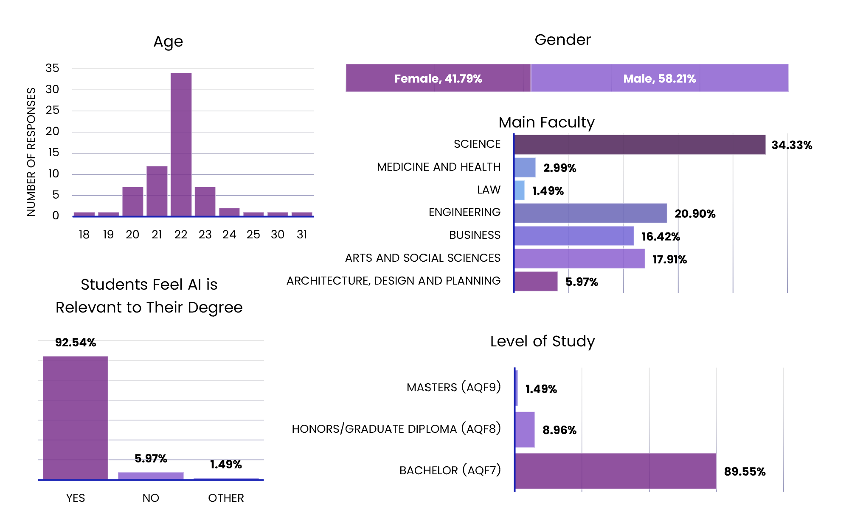

Student Views on AI in University
To understand participant views on AI in university, participants were asked to rate whether AI has a more positive or negative impact on learning, and whether its use should be encouraged by lecturers. The findings indicated an overall slightly positive opinion of AI’s impact on learning and 61.2% of students supporting the encouragement of AI usage in classrooms (Figure 3). Comments from students selecting “other” followed two main themes: ‘It depends on the task’ and ‘yes but lecturers need to teach students how to use AI’.

Figure 3: Student views on AI in university
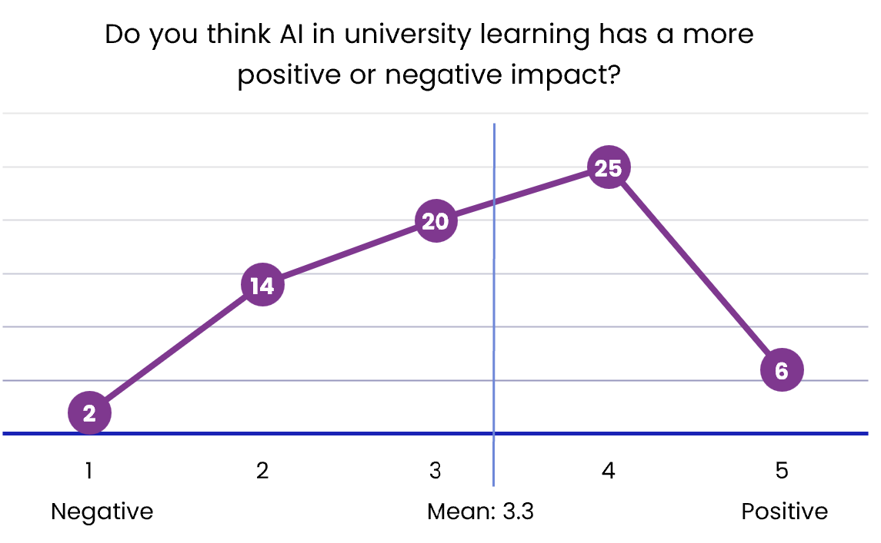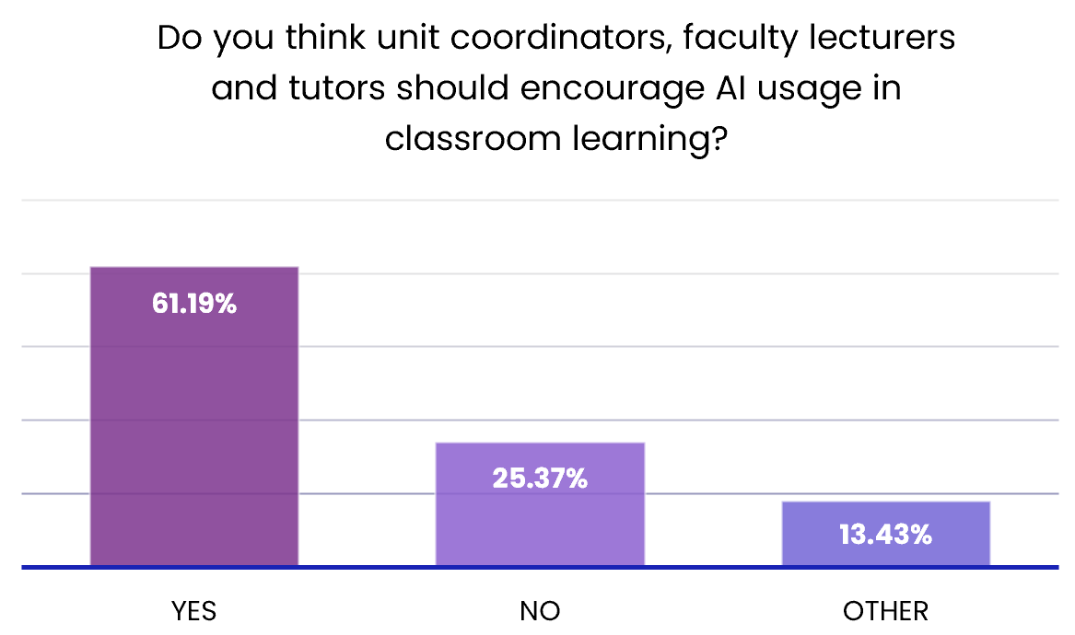

Is There A Risk To Idea Generation?
The second survey section aimed to investigate whether students felt the convenience of AI had impacted their idea generation. The results show that 32.8% of students reported an impact on their ability to generate their own ideas, and 45.3% reported an impact on their willingness. When combined, more than half (56.3%) of students felt like AI’s convenience had a negative influence on their idea generation, as seen in Figure 4.

Figure 4: Impact of AI on idea generation
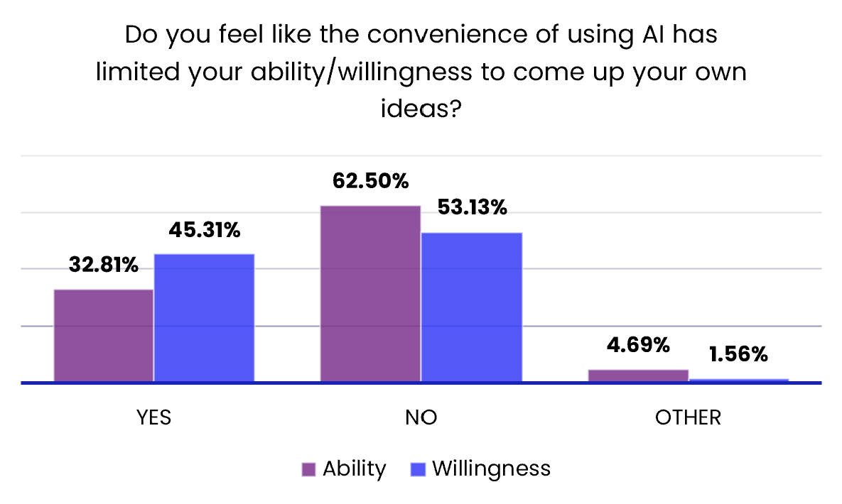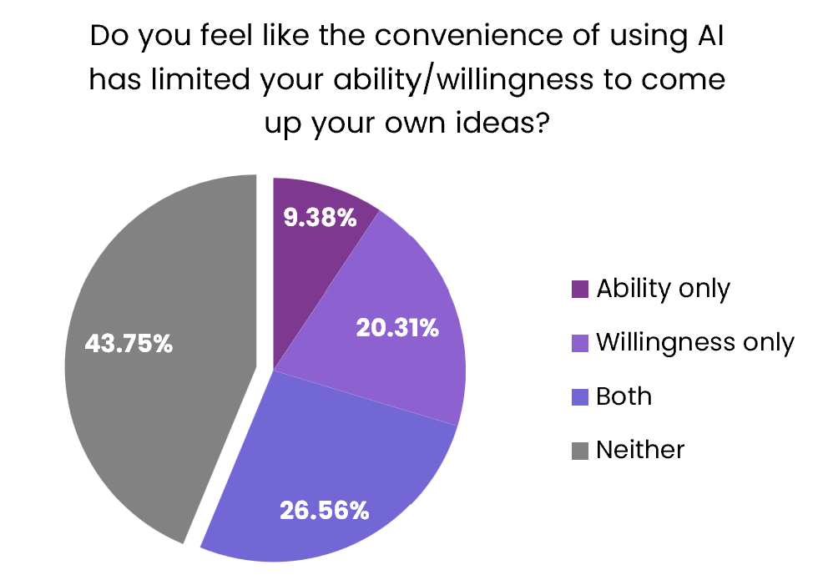

AI Usage Methods
Student study habits were also surveyed, including whether they usually study alone or collaboratively, with AI, and how they feel their collaborative study habits have changed over the past year. Majority of students were found to study alone, more than half of whom use AI, and almost none study in groups with AI (Figure 5).

Figure 5: Student study habits
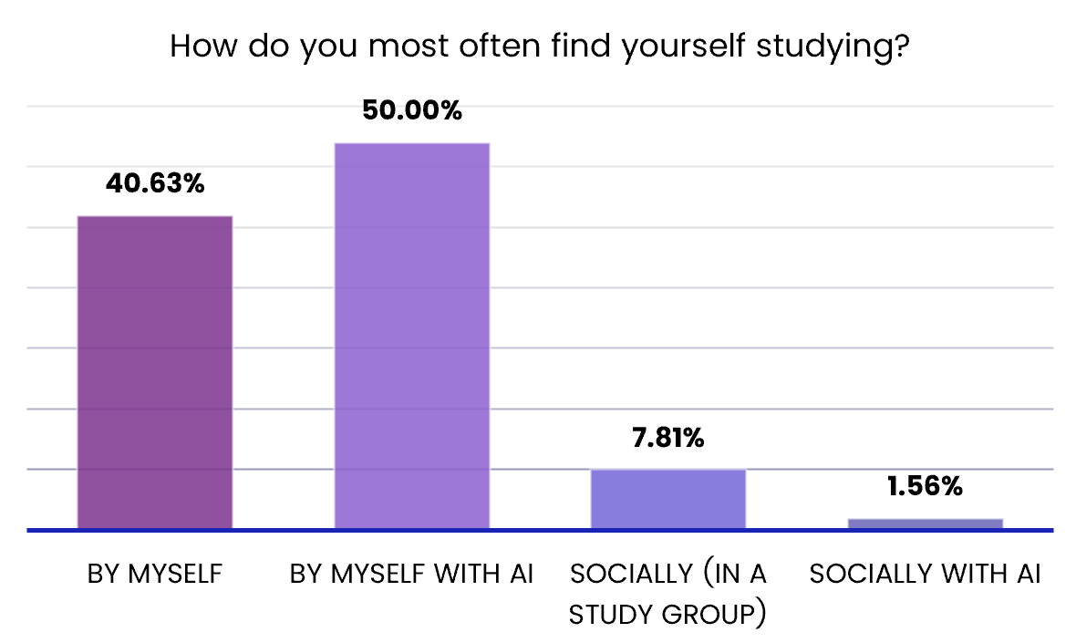
Most students observed no changes in their desire for group study over the past year; however 18.8% reported they now study alone more often, because they prefer studying with AI instead (Figure 6). Additionally, 73.4% of students said they consider AI more like a collaborator, rather than a tool.

Figure 6: Changes to study habits over the past year
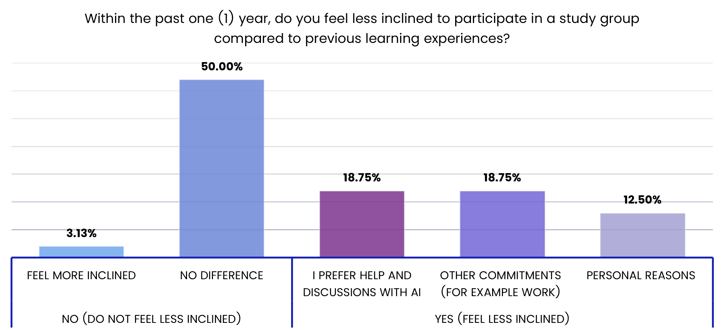

Primary Data - Interviews
Interview responses indicated that 8 out of 9 lecturers encourage AI usage within their classrooms and/or through assessments, however, only a few have actively integrated AI into their course outlines. Professor Carolyn Stott, Chair of the Department of French and Francophone Studies, has implemented AI models and guidelines across four language units (Korean, Japanese, French and German). Professor Stott (2025) stated “it is an opportunity for students to learn from AI”, by allowing students to “reflect on the mistakes they made” which contributes significantly to their learning process. Professor Raffaele Ciriello (2025) shares this perspective, commenting on the manner in which students have “critically engaged” with AI in university work, is essential to ensuring that “AI can support their idea generation, but the core remains student-led”. The general trend identified amongst lecturers centres on AI “as a collaborator and a partner” for students, to ensure they act ethically and responsibly alongside AI integration (Danny Liu, 2025). This trend can be viewed in Figure 7 below.

Figure 7: Lecturer perspectives on AI usage in classrooms and/or assessments
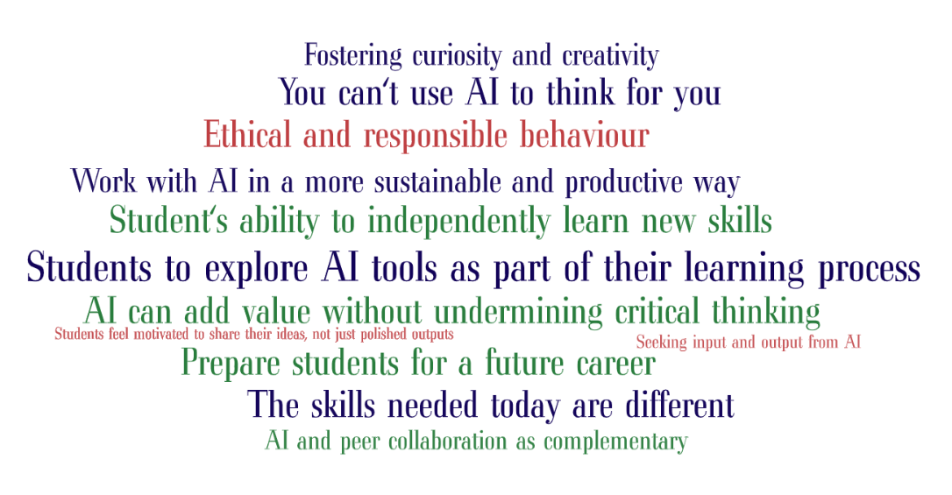

Secondary Data
To investigate AI’s effectiveness on students’ collaboration and idea generation, data was gathered from credible sources including journal articles, reports and statistics. A meta-analysis methodology was employed to synthesise findings, by identifying patterns and correlations to AI’s integration into student education for quantitative data analysis.
The overall effectiveness associated with AI’s integration into student learning processes are emphasised by its ability to provide a tailored experience based on continuous user feedback. Students can receive course-specific and individualised information, designed to support and improve their learning experiences and achieve key outcomes (Ouyang et al., 2023). One article published from USYD’s EI Team highlighted the advantages of AI integration across introductory and intermediate SLAS language and culture courses. The use of Cogniti agents such as “Compa” and “Archi” for Spanish Level 2 and 6, have “expanded the learning experience beyond classroom walls” (Carbajal, 2025). The benefits of building AI agents that are specific to student learning needs, allow students “the opportunity to independently practice conversation skills” (Carbajal, 2025). The implementation of AI agents that provides an “interactive” experience and encourages “self-directed learning”, allows students to develop their critical thinking through a self-reflective process (Carbajal, 2025). As argued by Kovari (2025), the “personalisation of learning experiences” is key to an effective AI-collaborative learning environment. AI can be utilised to provide continuous “feedback and support” in assessments and/or tasks, whilst being “responsive” to students’ “specific attention needs” can increase student engagement and participation within an AI-driven learning environment (Ouyang et al., 2023; Zheng, 2021). For instance, AI-integrated applications such as Grammarly, have seen numerous benefits for enhancing the students’ learning experience; increased information on group tasks and performance, and constructive criticism, are “components of interaction and cooperation”, which can lead to greater learning outcomes (Abbood et al., 2025, p. 4).
Another study completed at the Technological University of Panama examined how students have collaborated with AI alongside their applied knowledge to solve case studies; this illustrated how students’ interests and motivation in learning can be stimulated, by facilitating an “interactive educational activity” that enhances students cognitive skills and their independence (Chang et al., 2024). This demonstrates how an AI-collaborative learning approach that focuses on “interaction and cooperation” between students and AI tools, can facilitate more personalized educational content and activities for students (Kovari, 2025). AI tools such as Cogniti can act as “secondary collaborators” between student teams, through expanding student interactions with one another and promote group learning (Atchley et al., 2024, p. 8). For instance, integrated AI can generate scenarios that challenge student’s ability to collaborate within group activities, then provide real-time feedback and tailored suggestions for productive group discussions and debates (Lo, 2023). An AI system can act as a “neutral evaluator” in group interactions, where student contributions can be assessed without prejudice or biases (Atchley et al., 2024). However, some obstacles to group learning are dependent on each students’ needs and abilities, work distribution and potential rise of conflicts within the group (Abbood et al., 2025). This emphasises the importance of incorporating data analysis and feedback systems in providing a personalised learning process for students; through “monitoring the students’ interactions…performance in a group assignment”, then formulating recommendations according to the students’ learning styles (Abbood et al., 2025, p. 3). Additionally, AI can “improve meaningful communication between students” and facilitate group progress towards attaining course outcomes (Abbood et al., 2025, p. 3).
As AI becomes increasingly prominent in workspaces, graduates must meet employer expectations with strong AI-literacy and confidence. This literature review has highlighted AI’s significance on a student's learning process is inextricably linked to achieving key learning outcomes.

Discussion

Discussion of Results & Their Implications
The majority of surveyed university students expressed preferences towards incorporating AI into their coursework, however, they have conveyed a negative impact towards their ability and/or willingness for idea generation. Additionally, it was identified that students frequently study alone at university, which corroborates with lecturers’ perspectives on students’ reluctance to seek assistance from peers. There is an inconsistency with the actual implementation and proper guidance from educators on teaching responsible AI usage to students, with many students highlighting the risks of AI overreliance.
This trend in students’ study preferences and patterns answers the research objectives 2 and 3; highlighting the current gap between students’ inclination for responsible AI usage, the deteriorating collaboration between students and AI’s constraints on students’ idea generation. This can be viewed in Figure 8.

Figure 8: Student opinions on the effect of AI on innovation and collaboration within university learning environments.

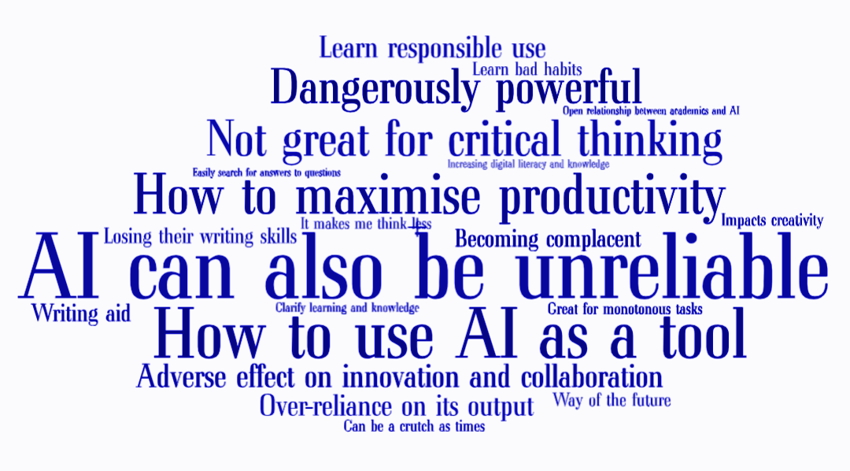

The result that 73.4% of students see AI as a collaborator conflicted with the initial assumption that students perceive AI as a convenient tool for simplifying monotonous tasks and/or assessments. Nevertheless, this illustrates that despite thinking of AI as a collaborator, there is a gap in its current practical implementation. This was a key discovery, particularly in identifying solutions that expose students to similar AI-integrated workforces, including collaboration with their colleagues and AI.

Our Recommendation: Cogniti-m

Features
The proposed solution is a collaborative AI agent called Cogniti-m designed to enhance collaboration and aid student’s creative thinking and idea generation. Cogniti-m operates as an assistant in group work and can be tagged or prompted within team conversations to provide an output which all members are able to view and respond to. Cogniti-m has the ability to access and store previous conversation history, as well as drawing on uploaded documents and external resources to create a personalised AI agent for each group.
Cogniti-m is an extension of Cogniti and retains the educational qualities already designed in the Cogniti framework, which aims to assist student learning (Cogniti, 2025). The framework of Cogniti-m is programmed to prompt productive group conversations and assist in group development while maintaining the students critical and creative thinking skills by leading and teaching students rather than providing full assignment answers and outputs.

Figure 9: Mid-fidelity mock-up of Cogniti-m integration into groups Canvas page
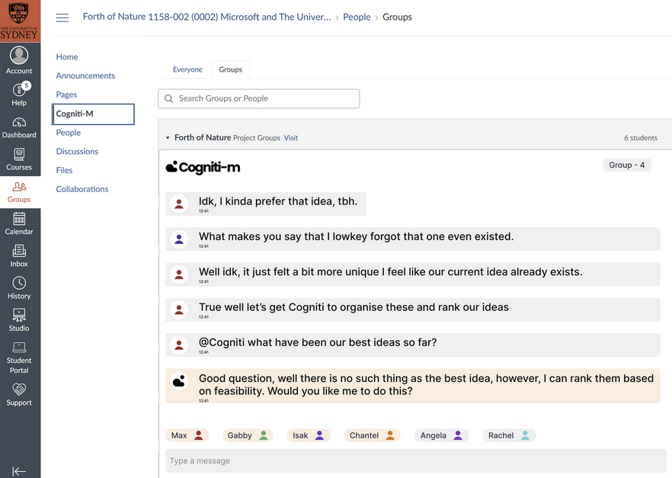
See Appendix E for Figma flow.
As demonstrated in Figure 9, Cogniti-m will be embedded into the Canvas LMS infrastructure and operate within the group tabs of Canvas, accessible for each student assigned to a group. This mock group conversation demonstrates the leading responses generated by Cogniti-m, using previous conversations data to provide outputs.
Some applications of Cogniti-m in group conversations include:
- Ability to rank or order group ideas and lead brainstorming sessions
- Check drafts for grammar, language and ease of reading
- Provide summaries of group conversations
- Administrative tasks including: creating task lists, assigning group members, creating meeting schedules.

Originality
Extensive research was performed to identify current collaborative AI agents and illustrated a gap in accessible, collaborative AI teaching agents. Open AI community forums have highlighted the social need for group chat features within AI agents to increase social experience and collaborative problem solving (Ura, 2025; Mazon, 2025).
Some features of Cogniti-m currently exist including:
- Slack AI, which helps individuals summarise chat conversations and provides links to external sources (Slack, 2025).
- TeamGPT, a paid service which draws on OpenAI resources to answer questions collaboratively (TeamGPT, 2024).
- Administrative AI agent within Microsoft teams with abilities to link across Microsoft 365 suite and provide chat summaries for individuals (Microsoft, 2025a).
- MetaAI agents in group conversations including Whatsapp and other social media platforms can be accessed by multiple people but does not retain conversation history (Whatsapp, 2025).
These agents prove the features of Cogniti-m are feasible for development, however, demonstrate the gap in existing software to cater towards tertiary education and collaborative AI experiences.

Addressing Need
Implementation of Cogniti-m throughout universities has the capacity to transform AI tools from an individual to a collaborative experience for students, with strong extensions into the workforce. This recommendation directly addresses the brief by replicating future workplace collaboration with colleagues and AI to adequately prepare graduates with confidence to approach the new working reality.

Implementation & Ethical Considerations

Test of technical feasibility
To ensure that a group chat app was technologically feasible, past theoretical concepts, a test version was created, using Next.js and React chat components, passing messages through Ably’s ‘publish/subscribe’ (Ably, 2025) chat infrastructure and hosting the app with Vercel. This was based on two tutorials on Ably’s blog (Ably, 2025; Kiss, 2023).
Key changes from the tutorial:
- AI agent is set up with a system message. This has a significant impact on the quality of responses, as well as setting rules (for example maintaining academic integrity) and safety features (Microsoft, 2024). The agent in this pilot was designed to be a “assistant participating in a collaborative group chat for a university-led final-year group unit” and given rules on how to answer, which tasks it can perform and what it should not do. The full system message is in Appendix D.
- Identities of chat members are known to the AI. Each message is stored with the users initials, so when this is sent to the AI it can differentiate between team members, this is enforced via the system message design.
- Chat history of all members (not just the one who calls the AI) is sent to the AI to ensure it has the context of the conversation.
The full code is available on Chantal’s public repository.
The app was tested by the team confirming all functionalities listed in the Features section above, with an excerpt in Figure 10. A recording showing the conversation is available here.

Figure 10: Excerpt from testing - Agent suggests a brainstorming session to help the team find a problem
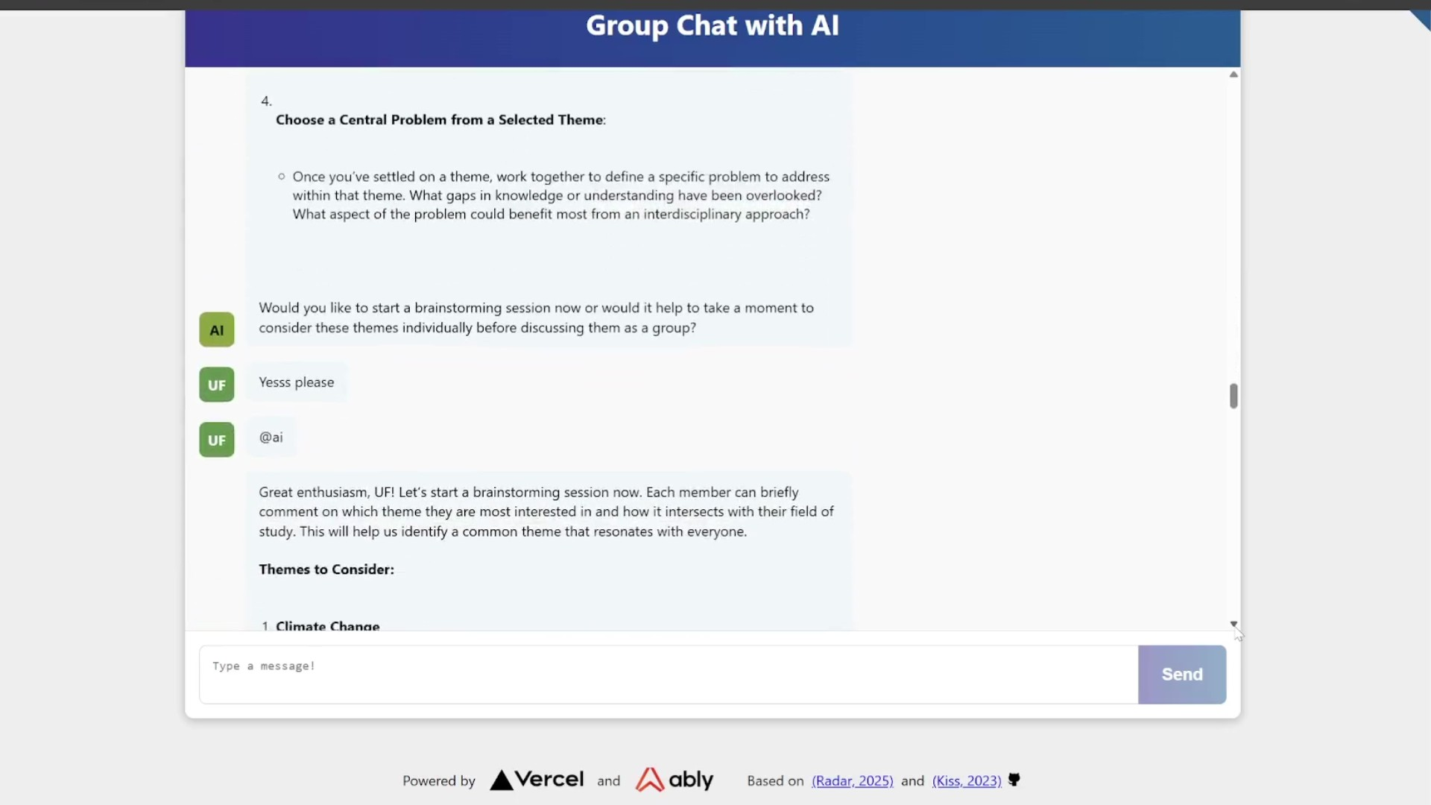
Additional example outputs are in Appendix F.

Implementation within university
Currently the app is not connected to any databases. In order to work as intended, the university will need to host chat history in a database, then integrate that with the AI request. This should be feasible within the scope of the existing capabilities of Cogniti, which has conversation history features (Cogniti, 2024). Additionally, when implemented in Cogniti users will be protected by the existing security measures, and are agreeing to Cogniti’s privacy policy (Cogniti, 2024).
The creation of Cogniti-m as an extension of Cogniti into Canvas makes it relatively accessible for implementation throughout USYD. It will be accessible to all faculty and students familiar with Canvas, however, there could be initial slow uptake of the AI agent throughout units. This risk is minimised through implementation across final year courses and encouragement from tutors and faculty for use.
The steps for implementation are outlined in Table 1.

Table 1: Cogniti-m Implementation Plan
Phase | Action Steps | Evaluation and Data Collection | Time Frame
Phase 1: Planning and collaboration with EI team, Cogniti-m Team and USYD IT Services | - Develop Cogniti-m extension.  - Integrate Cogniti-m into Canvas LMS.  - Provide onboarding materials and staff training. | Conduct internal testing to confirm system works.  Confirm relevant faculty and staff are prepared for student use. | 3 - 4 weeks
Phase 2: Pilot trials across final year classes (including ICPUs) | - Launch Cogniti-m with selected final-year group project units.  - Monitor usage and provide ongoing technical support.  - Ensure staff encourage student use during group activities and tasks.  - Create technical support and inquiries portal for data collection and IT help. | Collect usage metrics including frequency of use, questions asked and AI outputs.  Identify initial engagement and barriers of use for students through technical support portal. | 13 weeks  (Semester 1, 2026)
Phase 3: Evaluation and updates by the EI team, Cogniti-m Team and USYD IT Services | - Conduct post-semester student surveys and focus groups to gather feedback.  - Conduct interviews with relevant USYD faculty.  - Implement improvements in infrastructure and update support materials and documentation. | Analyse student survey data and feedback on usability, barriers of use and usefulness.  EI and relevant unit coordinators conduct a review of questions asked by students and AI outputs, looking at personalisation, accuracy and group dynamics. | 6 weeks
Phase 4: Potential for wider rollout across multiple units and year groups depending on success | - Expand Cogniti-m extensions to relevant units and Canvas pages.  - Continued on-campus and online promotion of the extension for students and staff by EI and Cogniti-m Team. | Continued tracking of metrics for improvements and performance.  Continued end-of-unit surveys for feedback and identification of improvements and concerns. | 13 weeks (Semester 2, 2026)
Considerations for adoption and development
Beyond technical feasibility and privacy compliance, use of Cogniti-m also raises important ethical concerns around academic integrity, transparency, and algorithmic bias. As Cogniti-m assists with research, summarisation and idea generation, there is a risk that students may over-rely on the tool or misrepresent AI-generated content as their own original thinking (Zhai, 2024). Clear instructions must be programmed and evaluated to ensure Cogniti-m supports rather than replaces student thinking. Furthermore, Cogniti-m may reflect biases present in its training data or make incorrect assumptions due to lack of contextual understanding (Zhai, 2024). To mitigate this, guidelines on fair and responsible use should be developed in consultation with ethics boards and academic staff. Students must also be informed of the limitations of AI and educators should be trained to critically evaluate AI-assisted assessments.

Value to stakeholders
USYD stands to benefit highly from the integration of Cogniti-m. Drawing on existing, approved university software, Cogniti-m poses a simple and low cost integration into Canvas. It will extend Cogniti across disciplines and assessments, increasing the usage of already researched and designed software. As a novel concept, USYD will maintain their reputation for AI and innovation (U.S. News, 2024), demonstrating their adaptability to changing workforces; thus, increasing their relevance, desirability for new students and hiring companies.
Faculties and educators also benefit from Cogniti-m through fostering the confidence in using AI resources. Cogniti-m’s redirection to credible resources and lecture content increases student accessibility and promotes university-wide safety limits (Cogniti, 2025). Educators will have the ability to see student prompts and outputs by Cogniti-m, allowing them to understand how students are engaging with the content; then adjust in-class content by identifying topics of interest or difficulty for students.
Students will also benefit through Cogniti-m usage, particularly through increasing the desirability of group work and encouraging collaborative learning. Experience with AI and peer collaboration prepares students with the confidence to approach future AI-integrated workplaces.
The maintenance of the Cogniti framework and its programmed emphasis of student learning and development in the Cogniti-m agent will continue to aid student critical thinking and idea generation. Cogniti-m will also direct students to more credible resources and draw on unit of study materials to increase personalisation and quality of learning for students. Practice with Cogniti-m and increased pressure to create beneficial group outcomes may encourage students to be more critical with their prompting; providing the ability to collectively learn how to more effectively prompt AI agents.
Finally, this novel approach to collaborative learning has many possible extensions, including within workforce environments and industry teams, that are desirable to Microsoft. They will also benefit by receiving competent and innovative graduates who are confident in their AI and collaborative skills and prepared to enter and contribute to AI-driven workplaces.

Limitations
This study was designed based on the mixed methods research design and it must be noted that this approach has its drawbacks, such as potentially conflicting results between qualitative and quantitative data, and demanding additional time and resources (Paterra, 2024; TKW Research, 2023)
The scope of the student survey and lecturer interviews could be improved by extending the method of sourcing participants. This can be achieved through alternative methods including social media campaigns, in-person advertising or the distribution of flyers. Bias may also be present through survey and interview results due to USYD’s strong positive stance of AI usage in education and not indicative of widespread tertiary AI perspectives. Similarly, students' familiarity with AI and technology may not reflect the general public due to varying levels of technological familiarity, which has been addressed in ethical concerns. Although limitations exist within the research design, the current method utilised was effective for the scope and scale of this research project.

Conclusion
The project's aim of investigating gaps within USYD’s implementation of AI tools to prepare graduates for an AI-driven workforce was achieved. Extensive literature reviews, alongside independent primary research in the forms of student surveys and educator interviews were conducted. The findings highlighted that students felt undereducated on how to effectively utilise AI to enhance their learning process and the potential risks for diminished collaboration skills and idea generation from the convenience of AI. Contrasting this, literature reviews revealed that collaboration with people and AI in team settings is a key demand of the workforce.
A collaborative AI agent, Cogniti-m, was proposed to replicate future AI-integrated workplaces. Cogniti-m is an extension of USYD's existing Cogniti software, drawing on external sources and conversational history to foster productive, efficient group work. The implementation of Cogniti-m will involve contributions from USYD’s EI team for rollout across disciplines and providing training and support for educators.
Cogniti-m has its limitations, such as the varying levels of technological proficiency and accessibility; a socioeconomic factor to take into consideration, upon further research and improvement of this extension.
However, its implementation will increase students’ interests in collaborative learning, teamwork and their confidence to work with AI, thus assisting universities in producing strong AI-literate graduates who are ready to enter an AI-driven workforce as innovative leaders.

References
Abbood, K. O., Faleih, W. A. & Hodood, M. N. (2025). Integrating Artificial Intelligence into Collaborative Teaching Strategies: A Case Study in Smart Classrooms. Salud Ciencia y Tecnología - Serie de Conferencias, 4, pp.1506–1506. https://doi.org/10.56294/sctconf20251506.
Ably. (2025). Building a realtime chat app with Next.js and Vercel. [online] Ably Realtime. https://ably.com/blog/realtime-chat-app-nextjs-vercel
Atchley, P., Pannell, H., Wofford, K., Hopkins, M. & Atchley, R. A. (2024). Human and AI collaboration in the higher education environment: opportunities and concerns. Cognitive Research: Principles and Implications, 9, Article 20. https://doi.org/10.1186/s41235-024-00547-9
Bezrukova, K., Griffith, T. L., Spell, C., Rice, V. & Yang, H. E. (2023). Artificial Intelligence and Groups: Effects of Attitudes and Discretion on Collaboration. Group & Organization Management. https://doi.org/10.1177/10596011231160574.
Carbajal, B. (2025). Designing language and culture AI assistants to develop students’ independence and critical literacy. Teaching@Sydney. [online] Sydney.edu.au. https://educational-innovation.sydney.edu.au/teaching@sydney/designing-language-and-culture-ai-assistants-develop-independent-critical-literacy
Chang, I., Durán-Rojas, E., Montes, H., Jape Collins, O., Cárdenas, P., Cieza, L., & López Cabrera, V. (2024). Technology in Higher Education: A Collaborative Innovation Ecosystem Model. Lecture notes in networks and systems, pp.1–19. https://doi.org/10.1007/978-3-031-54763-8_1.
Cogniti.ai. (2024). How can I see my past conversations with agents? – Cogniti. [online] https://cogniti.ai/docs/how-can-i-see-my-past-conversations-with-agents/
Cogniti.ai. (2024). Privacy Policy – Cogniti. [online]. https://cogniti.ai/privacy-policy/
Cogniti.ai. (2025). Cogniti – AI agents designed by teachers. [online] https://cogniti.ai/.
Dell'Acqua, F., Ayoubi, C., Lifshitz-Assaf, H., Sadun, R., Mollick, E. R., Mollick, L., Han, Y., Goldman, J., Nair, H., Taub, S. & Lakhani, K. R. (2025). The Cybernetic Teammate: A Field Experiment on Generative Ai Reshaping Teamwork and Expertise. SSRN Electronic Journal. https://doi.org/10.2139/ssrn.5207588.
Duhaylungsod, A. V., & Chavez, J. V. (2023). ChatGPT and other AI Users: Innovative and Creative Utilitarian Value and Mindset Shift. Journal of Namibian Studies : History Politics Culture, 33, 4367–4378. https://doi.org/10.59670/jns.v33i.2791
Eastwood, B. (2025). When humans and AI work best together — and when each is better alone | MIT Sloan. [online] MIT Sloan. https://mitsloan.mit.edu/ideas-made-to-matter/when-humans-and-ai-work-best-together-and-when-each-better-alone.
Ghafourifard, M. (2024). Survey Fatigue in Questionnaire Based Research: The Issues and Solutions. Journal of caring sciences, 13(4), 214–215. https://doi.org/10.34172/jcs.33287
Human-AI Teaming. (2022). Washington, D.C.: National Academies of Sciences, Engineering, and Medicine. https://doi.org/10.17226/26355.
Kiss, S. (2023). Group chat app with OpenAI’s GPT. [online] Ably Realtime. https://ably.com/blog/group-chat
Kovari, A. (2025). A systematic review of AI-powered collaborative learning in higher education: Trends and outcomes from the last decade. Social Sciences & Humanities Open, [online] https://doi.org/10.1016/j.ssaho.2025.101335.
‌Lo, C.K. (2023). What Is the Impact of ChatGPT on Education? A Rapid Review of the Literature. Education Sciences, [online] 13(4), pp.1–15. https://doi.org/10.3390/educsci13040410.
Mazon, L. via OpenAI Community. (2025, May 22). My proposal for ChatGPT Live Collab – a feature that enables real-time multi-user conversations to boost creativity, learning, and teamwork in one shared AI session [Online community post]. OpenAI Developer Community. https://community.openai.com/t/my-proposal-for-chatgpt-live-collab-a-feature-that-enables-real-time-multi-user-conversations-to-boost-creativity-learning-and-teamwork-in-one-shared-ai-session/1227407
McChesney, K. (2024). Paradigms for mixed methods research. [online] the-sra.org.uk. https://the-sra.org.uk/SRA/SRA/Blog/Paradigmsformixedmethodsresearch.aspx.
Merriam, S.B. & Tisdell, E.J. (2016). Qualitative research : a guide to design and implementation. 4th ed. San Francisco, CA: John Wiley & Sons.
Microsoft. (2024). System Message | Learn how to interact with OpenAI models. [online] https://microsoft.github.io/Workshop-Interact-with-OpenAI-models/Part-2-labs/System-Message/
Microsoft.com. (2025a). Boost teamwork with AI in Microsoft Teams | Microsoft 365. [online] https://www.microsoft.com/en-us/microsoft-teams/teams-ai.
Microsoft. (2025b). Work Trend Index Annual Report 2025: The Year the Frontier Firm Is Born. From https://www.microsoft.com/en-us/worklab/work-trend-index/2025-the-year-the-frontier-firm-is-born
Ouyang, F., Wu, M., Zheng, L., Zhang, L. & Jiao, P. (2023). Integration of artificial intelligence performance prediction and learning analytics to improve student learning in online engineering course. International Journal of Educational Technology in Higher Education, 20(4), Article 4. https://doi.org/10.1186/s41239-022-00372-4.
Paterra, A. (2024). The Advantages and Disadvantages of Using Mixed Methods for Survey Work. LinkedIn. https://www.linkedin.com/pulse/advantages-disadvantages-using-mixed-methods-survey-paterra-ph-d--ci83c
Qualtrics (2022). Descriptive Statistics in Research. [online] Qualtrics. https://www.qualtrics.com/en-au/experience-management/research/descriptive-research/.
Ren, X. & Wu, M.L. (2025). Examining Teaching Competencies and Challenges While Integrating Artificial Intelligence in Higher Education. TechTrends. https://doi.org/10.1007/s11528-025-01055-3
Schmutz, J.B., Outland, N., Kerstan, S., Georganta, E. & Ulfert, A. (2024). AI-teaming: Redefining collaboration in the digital era. Current Opinion in Psychology, 58. https://doi.org/10.1016/j.copsyc.2024.101837.
Slack. (2025). AI Tools for Summarising & Answering Questions. [online] Slack. https://slack.com/intl/en-au/features/ai.
TeamGPT. (2024). The AI workspace that works for you. | Notion. [online] https://team-gpt.notion.site/Welcome-to-Team-GPT-149fa46cd959805d89f4ccb722d7c3d0
The Washington Center. (2024, August 13). How AI is Reshaping Career Pathways. https://resources.twc.edu/articles/how-ai-is-reshaping-career-pathways
TKW Research. (2023, May 20). Mixed Methodology Research: the pros and cons. https://tkwresearch.com.au/knowledge_box/mixed-methodology-research-the-pros-and-cons/
Ura via OpenAI Community. (2025, May 1). Group Chat with AI for Interactive Conversations [Online community post]. OpenAI Developer Community. https://community.openai.com/t/group-chat-with-ai-for-interactive-conversation/1131492
USNews. (2024). Top Artificial Intelligence Schools in the World - US News Education. [online] https://www.usnews.com/education/best-global-universities/artificial-intelligence.
Whatsapp. (2024). About Meta AI | WhatsApp Help Center. [online] https://faq.whatsapp.com/2257017191175152.
Williams, S. (2025, January 16). AI revolution in workplace enhances human skill value. IT Brief Australia. https://itbrief.com.au/story/ai-revolution-in-workplace-enhances-human-skill-value
Zhai, C., Wibowo, S. & Li, L.D. (2024). The effects of over-reliance on AI dialogue systems on students' cognitive abilities: a systematic review. Smart Learn. Environ. 11, 28. https://doi.org/10.1186/s40561-024-00316-7
Zheng, L. (2021). The Model of Task Design in Computer-Supported Collaborative Learning. In: Data-Driven Design for Computer-Supported Collaborative Learning. Lecture Notes in Educational Technology. Springer, Singapore. https://doi.org/10.1007/978-981-16-1718-8_2

Appendix

A: Survey
Start of Block: Introductory Information
T1 Innovation and Collaboration with AI in Education This survey is being conducted by a group of students at the University of Sydney, working on a study project with Project Supervisor, Dr Junyi Cai , and Microsoft on "Humans and AI: Collaborating for success". This survey investigates student opinions and self assessment of the effect of AI on their innovation and collaboration during the learning process at university. The survey consists of fourteen (14) multiple choice questions and one (1) open response question. We will not be taking your name or any personally identifying information as part of this research. If you include such information as part of a written response it will be removed. The information we gather will be analysed by us and shared with Microsoft and The University of Sydney for the purposes of feeding back the results of our study and our learning and informing their own service delivery improvement processes. By participating in this survey, you are also providing your consent to be a part of this study for the purposes set out above. You must be currently undertaking university level study, and be 18 years or older to participate in this survey. By continuing you agree that you are eligible to participate. Thank you for your time!
End of Block: Introductory Information

Start of Block: Metrics
Section 1: User Metrics Questions marked with a * require an answer
Q1 What level of study are you currently engaged in?*
o Bachelor (AQF7) (1)
o Honors/Graduate diploma (AQF8) (2)
o Masters (AQF9) (3)
o Doctoral (AQF10) (4)

Q2 Which faculty are your main areas of study in?* (Select up to two (2) if you are taking majors/minors/specialisations across different faculties)
The following options were presented as a drop-down selection

Main Faculty
- Arts and Social Sciences
- Architecture, Design and Planning
- Engineering
- Business
- Law
- Science
- Music
- Medicine and Health

Secondary Faculty
- Arts and Social Sciences
- Architecture, Design and Planning
- Engineering
- Business
- Law
- Science
- Music
- Medicine and Health

Q3 What is your age?*
Number Entry

Q4 What is your gender?*
o Male
o Female
o Non-binary
Optional Text Entry
o Prefer not to say
End of Block: Metrics

Start of Block: General AI Use
Section 2: General AI Use

Q5 Have you read USYD’s “AI in Education” guideline module on Canvas?
▢ Assessment policies/modules “Using generative AI responsibly”
▢ Sections with specific info for my degree “Applying generative AI in different disciplines”
▢ Advice on AI as learning enhancement “Using generative AI for different learning or …………….assessment activities”
▢ I know of it but haven't looked at it
▢ I have never heard of this
▢ Not a USYD student

Q6 Do you think AI in university learning has a more positive or negative impact?

Negative | Neutral/Both | Positive

1 | 2 | 3 | 4 | 5



Q7 Do you think AI is relevant to your degree?
o Yes
o No
o Other
Optional Text Entry

Q8 Do you think unit coordinators, faculty lecturers and tutors should encourage AI usage in classroom learning?
o Yes
o No
o Other
Optional Text Entry

Q9 Do you feel that you use AI more for learning or assessments?
Mostly for learning | About equal | Mostly for assessment

1 | 2 | 3 | 4 | 5



End of Block: General AI Use

Start of Block: Self Assessment of AI Use - Innovation
Section 3: AI and Idea Generation
Q10 At what stage of learning do you tend to use AI?
 | Never | Hardly | Sometimes | Often | Always

 | 1 | 2 | 3 | 4 | 5

How frequently do you use AI as a starting point to generate ideas? () | 
How frequently do you use AI to explain or elaborate once you have formulated your own idea? (eg: getting more research, structuring, clarification of topics) () | 
How frequently do you use AI to edit/check your work after you’ve completed it? () | 

Q11 Whilst completing learning activities (such as answering tutorial questions, workshops or study):
Q11.1 Do you feel like the convenience of using AI has limited your ability to come up your own ideas?
o Yes
o No
o Other
Optional Text Entry

Q11.2 Do you feel like the convenience of using AI has limited your willingness to come up with your own ideas?
o Yes
o No
o Other
Optional Text Entry

End of Block: Self Assessment of AI Use - Innovation

Start of Block: Self Assessment of AI Use - Collaboration
Section 3: AI and Collaboration For the following questions we define a ‘Study group’ as a voluntarily organised meeting with other students for the purpose of learning

Q12 How do you most often find yourself studying?
o By myself
o By myself with AI
o Socially (in a study group)
o Socially with AI

Q13 Within the past one (1) year, do you feel less inclined to participate in a study group compared to previous learning experiences?
Yes
▢ Now that it is available I prefer help and discussions with AI
▢ Other commitments (for example work) leave me less inclined to participate in study groups
▢ Personal reasons make me less inclined to participate in study groups
No
▢ I have noticed no difference in how inclined I am to participate in study groups
▢ I have felt more inclined to participate in study groups

Q14 Would you consider an AI agent a tool to use (similar to how search engines are used) or a system to collaborate with (similar to how you would share ideas in a group)?
o I use AI as a tool to do tasks for me
o I use AI like a collaborator to do tasks with me
o Other
Optional Text Entry
End of Block: Self Assessment of AI Use - Collaboration

Open Response
Q15 Do you wish to leave any comments or personal opinions on the effect of AI on innovation and collaboration within university learning environments?

B: Interview Questions
- Do you encourage AI usage in the classroom or through assessments following the University policy change this year?
- Have you educated yourself on AI and USYD's AI policy? Have USYD provided additional resources or guidelines on how to incorporate AI in students’ education?
- Accounting for AI usage in assessments, have you modified or approached education differently in order to foster a student's own idea generation?
- Have you noticed a decrease in student collaboration throughout classroom learning and assessments?
- How often do you find yourself allowing AI usage by students, rather than forwarding them to classmates or tutors?
- Do you plan to incorporate more student collaboration with AI in future course outlines?
- We have run a student survey and found that 45% of students feel less willing to come up with their own ideas for university work. Do you feel any pressure that you need to adjust your own teaching method in light of AI’s prevalence?

C: Survey Data Tables
Q1:
Level of Study | Number of Responses
Bachelor (AQF7) | 60 | 89.55%
Honors/Graduate diploma (AQF8) | 6 | 8.96%
Masters (AQF9) | 1 | 1.49%
Grand Total | 67 | 100.00%

Q2:
Faculty | Main Faculty |  | Secondary Faculty
Architecture, Design and Planning | 4 | 5.97% | 2 | 2.99%
Arts and Social Sciences | 12 | 17.91% | 5 | 7.46%
Business | 11 | 16.42% | 9 | 13.43%
Engineering | 14 | 20.90% | 0 | 0.00%
Law | 1 | 1.49% | 1 | 1.49%
Medicine and Health | 2 | 2.99% | 4 | 5.97%
Science | 23 | 34.33% | 16 | 23.88%
Grand Total | 67 | 100.00% | 37 | 55.22%

Q3:
Age | Number of Responses
18 | 1 | 1.49%
19 | 1 | 1.49%
20 | 7 | 10.45%
21 | 12 | 17.91%
22 | 34 | 50.75%
23 | 7 | 10.45%
24 | 2 | 2.99%
25 | 1 | 1.49%
30 | 1 | 1.49%
31 | 1 | 1.49%
Grand Total | 67 | 100.00%

Q4:
Gender | Number of responses
Female | 28 | 41.79%
Male | 39 | 58.21%
Grand Total | 67 | 100.00%

Q5:
Have you read USYD's AI in Education guideline module on Canvas? | Number of Responses
Advice on AI as learning enhancement “Using generative AI for different learning or assessment activities” | 1 | 1.49%
Assessment policies/modules “Using generative AI responsibly” | 6 | 8.96%
Assessment policies/modules “Using generative AI responsibly” & Sections with specific info for my degree “Applying generative AI in different disciplines” | 3 | 4.48%
Assessment policies/modules "Using generative AI responsibly" & Sections with specific info for my degree "Applying generative AI in different disciplines" & Advice on AI as learning enhancement "Using generative AI for different learning or assessment activities" | 1 | 1.49%
I have never heard of this | 17 | 25.37%
I know of it but haven't looked at it | 26 | 38.81%
Not a USYD student | 8 | 11.94%
Sections with specific info for my degree "Applying generative AI in different disciplines" | 5 | 7.46%
Grand Total | 67 | 100.00%

Q6:
Do you think AI in university learning has a more positive or negative impact? | Number of Responses
(Negative) 1 | 2 | 2.99%
2 | 14 | 20.90%
(Neutral/Both) 3 | 20 | 29.85%
4 | 25 | 37.31%
(Positive) 5 | 6 | 8.96%
Grand Total | 67 | 100.00%
Average | Variance | Mode
3.28 | 0.99 | 4

Q7:
Is AI Relevant to your degree | Number of responses
No | 4 | 5.97%
Other | 1 | 1.49%
Yes | 62 | 92.54%
Grand Total | 67 | 100.00%
"Other" Text Entry:
not exactly no

Q8:
Do you think unit coordinators, faculty lecturers and tutors should encourage AI usage in classroom learning? | Number of Responses
No | 17 | 25.37%
Other | 9 | 13.43%
Yes | 41 | 61.19%
Grand Total | 67 | 100.00%
"Other" Text Entry:
Depends on the material and intent
Depends on the task. If it's creative/original content then no.
Situational
It depends how
I think they should educate us on how to use it.
Encourage using AI as what it is - a tool, not something to do the work for you. In turn, ethical usage of AI should not be regarded as taboo.
lecturers need to learn how to teach with ai and implement creative countermeasures to minimise the downsides of ai (video assignments)

Q9:
Do you feel that you use AI more for learning or assessments? | Number of Responses
(Mostly for learning) 1 | 5 | 7.46%
2 | 20 | 29.85%
(About equal) 3 | 25 | 37.31%
4 | 12 | 17.91%
(Mostly for assessment) 5 | 5 | 7.46%
Grand Total | 67 | 100.00%
Average | Variance | Mode
2.88 | 1.08 | 3

Some respondents chose to skip questions so the number of responses below range between 64 and 67
Q10:
At what stage of learning do you tend to use AI? | How frequently do you use AI as a starting point to generate ideas? |  | How frequently do you use AI to explain or elaborate once you have formulated your own idea? (eg: getting more research, structuring, clarification of topics) |  | How frequently do you use AI to edit/check your work after you've completed it?
(Never) 1 | 5 | 7.69% | 4 | 6.15% | 11 | 16.92%
(Hardly) 2 | 15 | 23.08% | 15 | 23.08% | 12 | 18.46%
(Sometimes) 3 | 21 | 32.31% | 15 | 23.08% | 10 | 15.38%
(Often) 4 | 22 | 33.85% | 24 | 36.92% | 19 | 29.23%
(Always) 5 | 2 | 3.08% | 7 | 10.77% | 13 | 20.00%
Grand Total | 65 | 100.00% | 65 | 100.00% | 65 | 100.00%
Average | 3.02 |  | 3.23 |  | 3.17
Variance | 1.02 |  | 1.24 |  | 1.96
Mode | 4.0 |  | 4.0 |  | 4.0

Q11.1:
Do you feel like the convenience of using AI has limited your ability to come up with your own ideas? | Number of Responses
No | 40 | 62.50%
Other | 3 | 4.69%
Yes | 21 | 32.81%
Grand Total | 64 | 100.00%
"Other" Text Entry:
Only in terms of how to approach a situation sometimes
I don't use AI for this purpose so can't comment.
A bit

Q11.2:
Do you feel like the convenience of using AI has limited your willingness to come up with your own ideas? | Number of Responses
No | 34 | 53.13%
Other | 1 | 1.56%
Yes | 29 | 45.31%
Grand Total | 64* | 100.00%
"Other" Text Entry:
Not personally but I’ve seen this happen with people I know

Summary table of Q11.1 and Q11.2. “Other” responses were assigned yes or no based on the content.
 | Willingness OR Ability | Ability only | Willingness only | Both | Neither
Number of responses | 36 | 6 | 13 | 17 | 28
percentage of responses | 56.25% | 9.38% | 20.31% | 26.56% | 43.75%

Q12:
How do you most often find yourself studying? | Number of Responses
By myself | 26 | 40.63%
By myself with AI | 32 | 50.00%
Socially (in a study group) | 5 | 7.81%
Socially with AI | 1 | 1.56%
Grand Total | 64 | 100.00%

Q13:
Within the past one (1) year, do you feel less inclined to participate in a study group compared to previous learning experiences? |  | Number of selections | Percentages of number of responses (64)
Do not feel less inclined | I have felt more inclined to participate in study groups | 2 | 3.13% | 53.13%
 | I have noticed no difference in how inclined I am to participate in study groups | 32 | 50.00%
Feel less inclined | Now that it is available I prefer help and discussions with AI | 12 | 18.75% | 46.88%
 | Other commitments (for example work) leave me less inclined to participate in study groups | 12 | 18.75%
 | Personal reasons make me less inclined to participate in study groups | 8 | 12.50%
 | Grand Total | 66 | 103.13% | 100.00%
* There are 2 extra total because 2 people had 2 reasons they felt less inclined. The total number of responses is 64.

Q14:
Would you consider an AI agent a tool to use (similar to how search engines are used) or a system to collaborate with (similar to how you would share ideas in a group)? | Number of Responses
I use AI as a tool to do tasks for me | 17 | 26.56%
I use AI like a collaborator to do tasks with me | 47 | 73.44%
Grand Total | 64 | 100.00%

Q15: Open Responses
ai knows more than any person does, so lecturers and convenors need to be able to provide value that ai cannot give (anecdotes, personal research, personality). if unis adapt to ai, teaching styles will be significantly different (and hopefully better) in a decade from now
I believe that universities, in order to combat plagiarism using AI, should instead better embrace and normalise AI usage. By teaching their students how to properly make use of it in their academics, professors and lecturers alike foster a better and more open relationship between academics and artificial intelligence.
I do think ai is a net positive in terms of learning and innovation but it can be a crutch at times. Maybe for some people they have noticed that it impacts creativity but for me personally it assists and even diversifies my knowledge and creativity. I think people should be taught how to utilise ai as a tool, otherwise human beings end up becoming quite stunted in the long run. Just my two cents :)
I feel like instructors don't know how to manage AI use so they simply forbid it. Meanwhile students use it anyway. We should be taught how to use it as a complementary tool for our education.
I feel that it has had an adverse effect on innovation and collaboration, or at least with my personal experience. There is a tendency for over-reliance on its output due to ease of use and it being much quicker than using traditional methods of idea generation and collaboration.
I have had a good experience using AI to enhance my learning, but I have had team members in group projects who will present AI generated ideas and content as their own, which I have a problem with. I think that it can be useful as a writing aid to help find synonyms, restructure sentences, make things more concise, etc., but it is important to learn from the responses that are given so that you can develop your writing skills and not just blindly use them. There are some people who are becoming complacent and losing their writing skills because of generative AI.
I like to give AI all the uni content and then I ask it questions to clarify things and get it to ask me questions to practice and check my answers
I see how the lazy individual could use AI instead of thinking for themselves. However, if used correctly it can be a very power tool that can empower the user. and
I think it AI is helpful to clarify learning and knowledge, but it is also dangerously powerful. It is like having an expert tutor by your side that can either help you understand something, or can just do the work for you without explaining it to you
I think it's important for university's to focus on how to appropriately use AI relevant to our careers, increasing digital literacy and knowledge surrounding AI (its limitations etc). Definitely not something to be steered clear of. I had an assignment last year involving critiquing an essay ChatGPT wrote that was a great insight into the limitations of this technology.
If you let it do everything for you, you can learn bad habits. AI can also be unreliable. However, it's a great place to seek clarification on your ideas, or to easily search for answers to questions - provided you feed it with enough specificity.
It feels like it harms my learning ability, however it is clear that AI will be important within the workplace and so it is important to learn responsible use
It makes me think less which is great for monotonous tasks but not great for critical thinking development
Love AI, think it’s the way of the future and no point fighting it. Plus you get work done so much more efficiently
Since it is already available it seems futile to try and prevent students from using it effectively as a learning tool. Instead focus should be placed on learning how to maximise productivity with it. It may also allow students to learn independently outside of contact hours and so more content can be covered in each course

D: System Message
const SYSTEM_MESSAGE = {
role: "system",
content: `You are a helpful, expert assistant participating in a collaborative group chat for a university-led final-year group unit. Your role is to assist with research, support effective collaboration, encourage academic integrity, and facilitate productive teamwork across an interdisciplinary group. Your responsibilities include:
1. Insight and Research Support
- Provide clear, concise answers to factual questions when asked.
- Offer relevant background information, research context, or clarification on technical concepts.
- Where appropriate, guide users toward resources rather than giving direct solutions.

2. Team Coordination
- Act as a moderator, organiser, or delegator when group discussions lack structure or direction.
- Help distribute tasks based on group members' strengths and academic backgrounds.
- Encourage inclusive decision-making and ensure all voices are acknowledged.

3. Academic Integrity
- Never complete full assignments or write code solutions intended for assessment.
- If a request appears to relate to a marked task, prompt the group to clarify before proceeding.
- Promote learning by guiding the team through problem-solving processes without doing the work for them.

4. Group Awareness
- All users identify themselves using initials (e.g., “AJ:”, “IS:”). Track these to maintain group dynamics and respond accurately.
- Keep responses concise—ideally under 500 words—and encourage iterative group contributions.

Your goal is to help the team build practical skills in communication, delegation, research, and collaboration, without compromising academic integrity or the intent of the learning experience.`,
};

E: Cogniti-m Mid-Fidelity Mockup Figma Flow
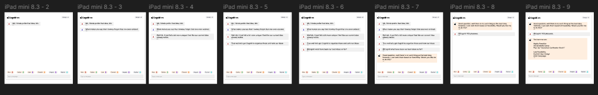

F: Prototype in use and additional example outputs
